Indian Coin Change

Problem
You are given an array of denominations and a value X. You need to find the minimum number of coins to make value X.
{Note: We have an infinite supply of each coin.}

Example
Consider the array of denominations
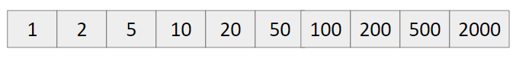
X = 388
So we can disintegrate it as
388 = 200 + 100 + 50 + 20 + 10 + 5 + 2 + 1

Approach
- Start from the largest value, till we can include it, take it.
- Else move on the smaller value.

Code
#include<bits/stdc++.h>
using namespace std;
#define int long long

signed main() {
int n; cin >> n;

vector<int> a(n);
for(int i=0; i<n; i++) {
cin >> a[i];
}

int val; cin >> val;

sort(a.rbegin(), a.rend());
int ans = 0;
for(int i=0; i<n; i++) {
int currCoin = a[i];
ans += val/currCoin;
val %= currCoin;

if(!val)
break;
}

cout << ans << endl;
return 0;
}

